**Team “Batman”**

1. Dimitar Andreev (D.Andreev)
2. Kolyo Kolev (Quasar)
3. Martin Shoilev (martin.shoilev)

# Project Description

Our team chose to develop one of the most popular game called “Chess”.Chess is a two-player [strategy](http://en.wikipedia.org/wiki/Abstract_strategy_game) [board game](http://en.wikipedia.org/wiki/Board_game) played on a [chessboard](http://en.wikipedia.org/wiki/Chessboard), a checkered gameboard with 64 squares arranged in an eight-by-eight grid. Each player begins the game with 16 [pieces](http://en.wikipedia.org/wiki/Chess_piece): one [king](http://en.wikipedia.org/wiki/King_(chess)), one [queen](http://en.wikipedia.org/wiki/Queen_(chess)), two [rooks](http://en.wikipedia.org/wiki/Rook_(chess)), two [knights](http://en.wikipedia.org/wiki/Knight_(chess)), two [bishops](http://en.wikipedia.org/wiki/Bishop_(chess)), and eight [pawns](http://en.wikipedia.org/wiki/Pawn_(chess)). Each of the six piece types [moves](http://en.wikipedia.org/wiki/Chess#Movement) differently. Pieces are used to attack and capture the opponent's pieces, with the objective to '[checkmate](http://en.wikipedia.org/wiki/Checkmate)' the opponent's king by placing it under an inescapable threat of capture. In addition to checkmate, the game can be won by the voluntary[resignation](http://en.wikipedia.org/wiki/Resign) of the opponent, which typically occurs when too much [material](http://en.wikipedia.org/wiki/Material_(chess)) is lost, or if checkmate appears unavoidable. A game may also result in a [draw](http://en.wikipedia.org/wiki/Draw_(chess)) in several ways, where neither player wins. The course of the game is divided into three phases: [opening](http://en.wikipedia.org/wiki/Chess_opening" \o "Chess opening),[middlegame](http://en.wikipedia.org/wiki/Chess_middlegame" \o "Chess middlegame), and [endgame](http://en.wikipedia.org/wiki/Chess_endgame).

Gameplay:  
Before starting the game the user must login. And he can create a new account or he can login with an existing account. After that he goes to the waiting room where he could choose his opponent. When one of the players accepts the invitation, the game starts. The game is played with mouse.

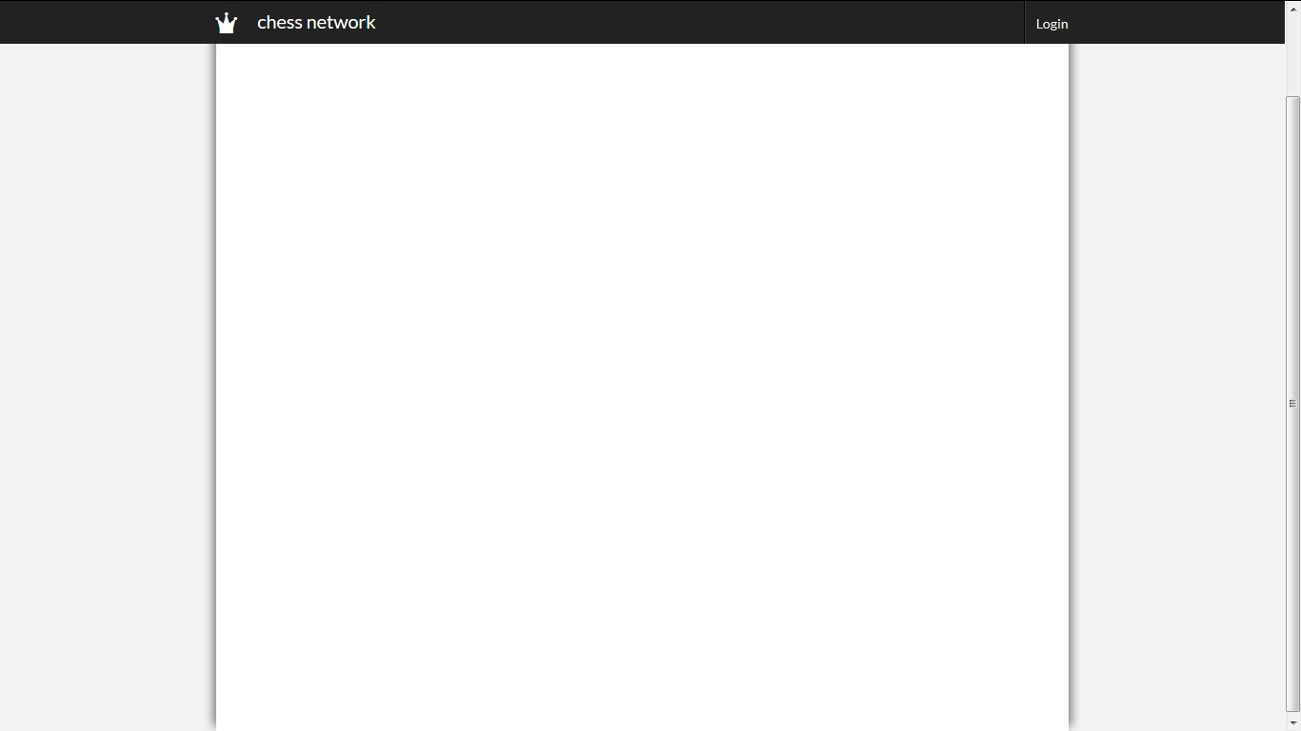

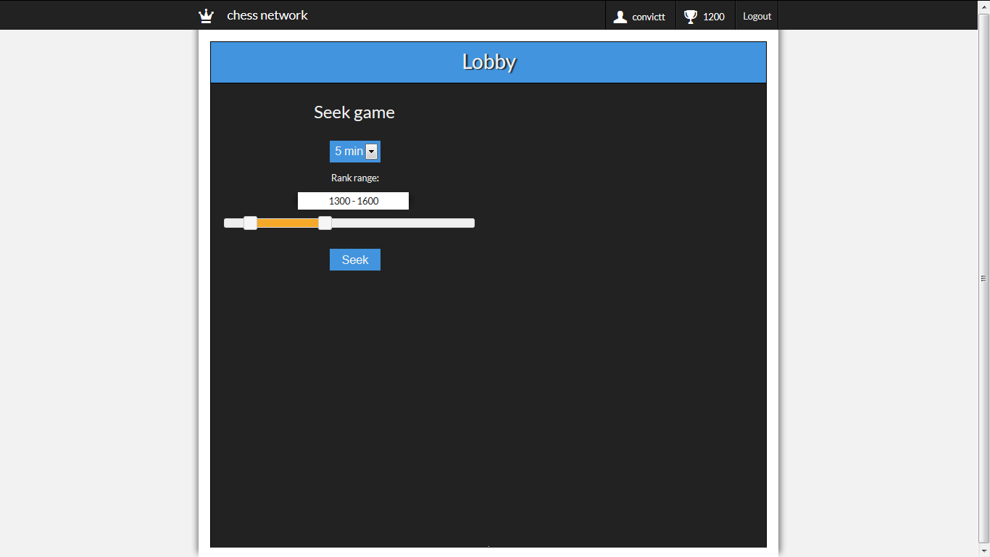

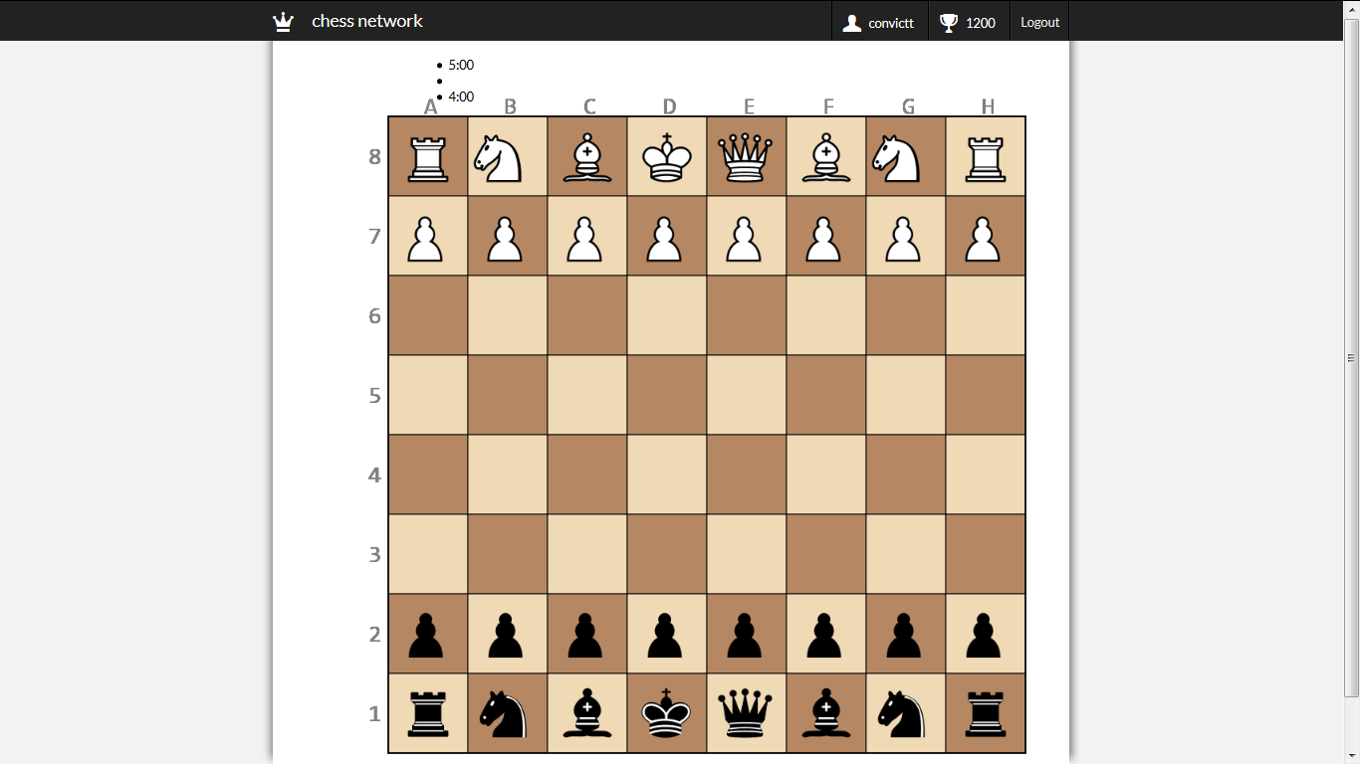

The project satisfies completely the general requirements of the assignment.

It has the following elements:

1. **Use the HTML5 canvas:**

* ***We draw the playfield and figurines with Canvas***

1. **Use SVG**
2. **Create animations**

* **For animation we used canvas**

1. **The application must work in the latest versions of the browsers: Google Chrome, Mozilla Firefox, Internet Explorer 10/11, Opera and Apple Safari**

* **Our application works on every of these browsers.**

1. **Use DOM manipulations like native DOM API or jQuery :**

* ***We use jQuery in our application***

1. **Implementation of server-side logic with ASP.NET, PHP, Java or Node.js**

* ***We implement a server side logic using Node.js***

https://github.com/D-Andreev/Chess-Network